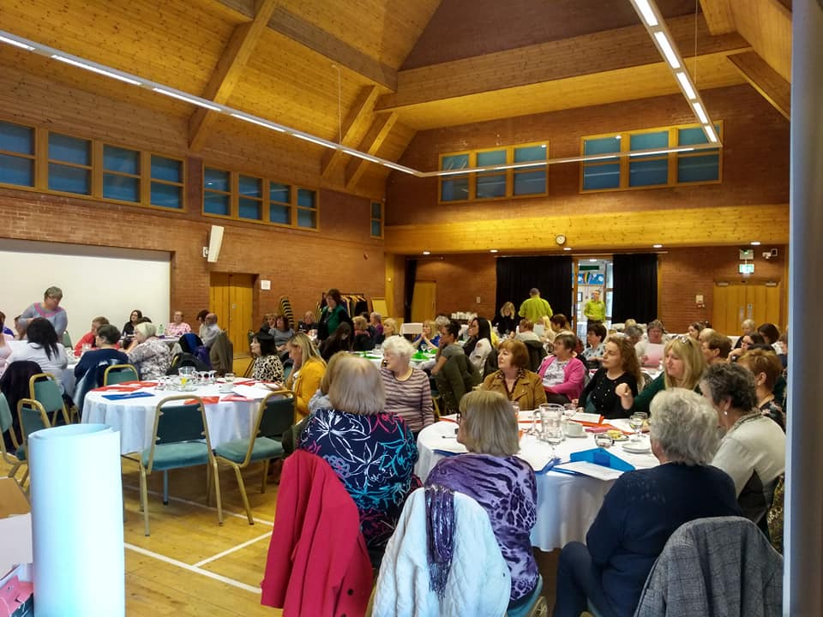

Legacy…..

Speaking Truth to Power

2018

March 21st 2019
Grosvenor Conference Centre Belfast

Women’s Information Northern Ireland

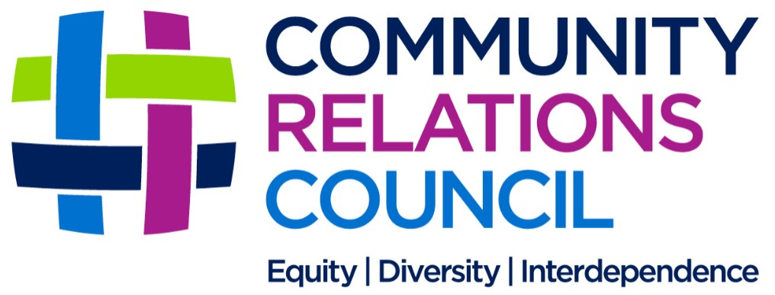
Argyle Business Centre
39 North Howard Street
Belfast
BT13 2AP
Tel. 028 9023 1876
caroline@womensinformationnorthernireland.com
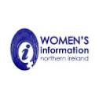
This project was funded by the
Community Relations Council
Core Funding and Small Grants Programmes.

Women’s Words Project
Phase 1

Finale Conference Report

A Forty Year Journey………
WINI’s mission is to “create a space for women, from across all communities, to come together to –
share experiences, raise issues and access a range of topical up-to-date information encouraging a positive impact on themselves, their families and the wider community”
Women’s Information has been working since 1980 to support women in their local communities to raise awareness on the many issues that affect women’s lives.
Women’s Information Group, as it was known in the early years, supported women living in working class areas of Belfast, through the most difficult times, helping them to engage with one another across community divides and ensuring their voices were heard at the policy making and decision-making tables.

In recent years the focus has become Northern Ireland wide and through its
Women’s Words Project, community conversations, roadshows, conferences and issue-based events have been held in many areas and the community conversation base has grown considerably.

The main focus is on helping to hear from grassroots women on the issues most affecting their daily lives and the lives of their families, how austerity issues and welfare reform is impacting women in particular, childcare provision or lack of it, culture and tradition and building a shared society, sectarianism and racism, health and wellbeing including mental health provision and developing peaceful, strong and resilient communities.

Women’s Information also has a goal of sharing information and providing opportunities for women to be well informed as this is important in empowering women to make decisions for themselves.

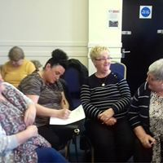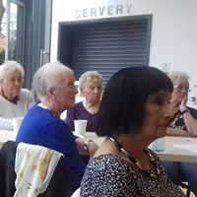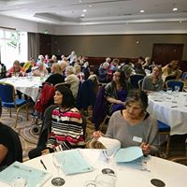

WINI’s mission is to “create a space for women, from across all communities, to come together to – share experiences, raise issues and access a range of topical up-to-date information that encourages positive impact on themselves, their families and the wider community.”

Women’s Words Project
WINI’s Women’s Words Project was established six years ago to engage women from across the community divides in Northern Ireland to encourage and enhance the role of women in peacebuilding and to develop links with policy makers, local government and the various departments of the Northern Ireland Assembly. The Women’s Words Project was created to help give women a voice and a platform to be heard, supporting grass roots women’s important role in creating peaceful, inclusive, just and shared communities.
This has been achieved using a specific model of engagement, Geographical Information Groups (GIGS), supported by local organisations and women from specific areas, who have regularly come together to dialogue, share experiences and work and learn together, get informed and create links to other support and resources. Participants in the GIGs have given input to a range of WINI themed events, roadshows, consultations, conferences, roundtables and community conversations and then use their local networks to cascade the information. Within these processes, women have identified the commonality of issues facing women across the sectarian divide.
This process was facilitated by Caroline McCord, the then newly appointed Community Relations
Co-Ordinator, who with the support of core funding from the Community Relations Council, brought this important project to life. Caroline worked tirelessly to establish and enhance the GIGS. Six months ago, Caroline moved to a new Health and Wellbeing Development role within WINI and
Anne Carr, a community relations and dialogue practitioner and facilitator came onboard to bring the first phase of Women’s Words to fruition.

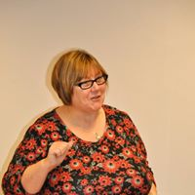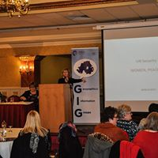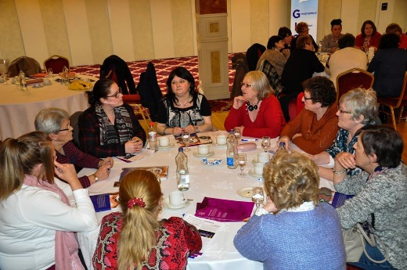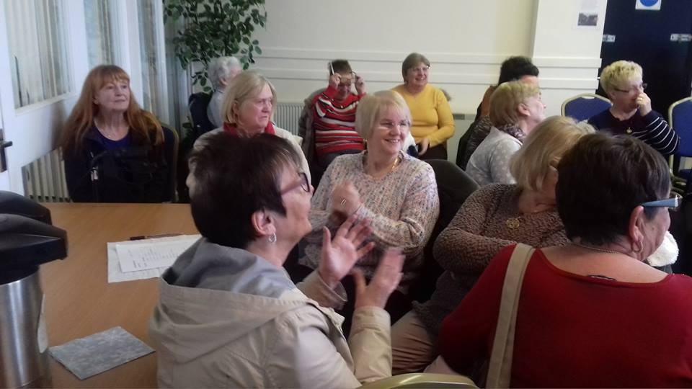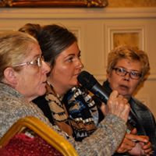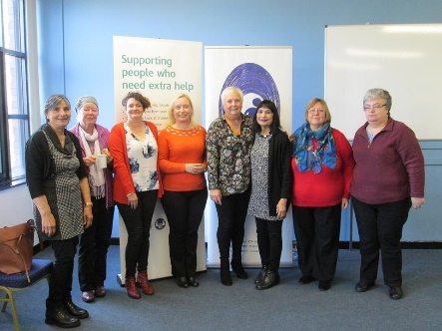

Throughout the lifetime of this project, women have raised many concerns including “bread and butter” issues such as debt and welfare reform, lack of affordable childcare, health and wellbeing issues and a myriad of “contentious issues” including ongoing paramilitary activity, interface violence, disputes over cultural and identity issues etc. They have further highlighted ongoing sectarianism and the continued exclusion and silencing of women in their desire to come to acceptable accommodations on these issues locally and in peace building initiatives in general. They have also raised broader women’s issues such as gender equality and the barriers to women’s participation in community and public life which is recognized globally as crucial to the development of a truly shared and peaceful society.
Many issues raised by grass roots women during these events have been captured and written up and presented to various government officials, MLA’s and other political and consultative forums through a range of key partners and alliances and in face to face conversations with others who work in the policy and legislative arena.
This includes work around implementation of Women, Peace and Security (UNSCR 1325) with the
All-Party Group at Stormont, the Women’s Caucus group and recent trip to the United Nations Commission on the Status of Women Conference (CSW63) in New York where, sponsored by the Icelandic Government, Anne Carr, was a keynote speaker at several global sessions including the Icelandic Government’s Women and Peacebuilding event, the event to support the launch of Peace Is Loud, Women and War II film trilogy, hosted by the Irish Mission and chaired by Charlie Flanagan, TD, Department of Foreign Affairs. Anne was able to share the history of Women’s Information from the early days of the conflict, to working to create our peace process and the need to involve women in all areas of peace building. Anne was also invited by our partners, Community Dialogue, to participate in the community engagement event in April in the Duncairn Centre, North Belfast with Theresa May, Prime Minister and Karen Bradley, Secretary of State for Northern Ireland and share what women were saying at our recent events looking at implementing our Belfast/Good Friday Agreement and the complex realities facing Northern Ireland and particularly border communities re BREXIT. Women working with WINI also organised a meeting with Simon Coveney, TD on these important issues.

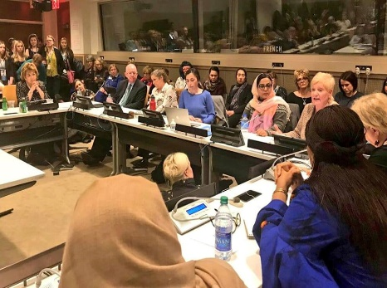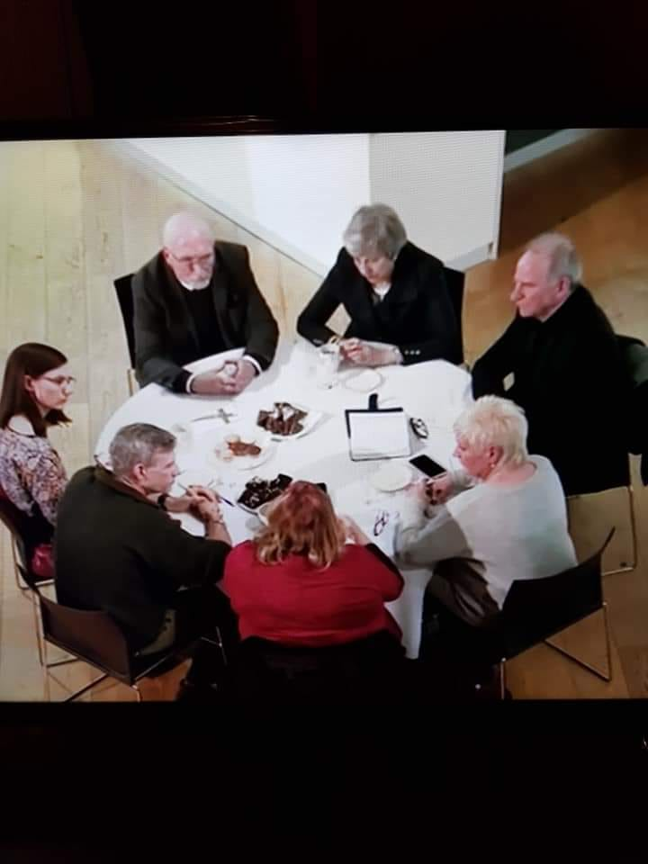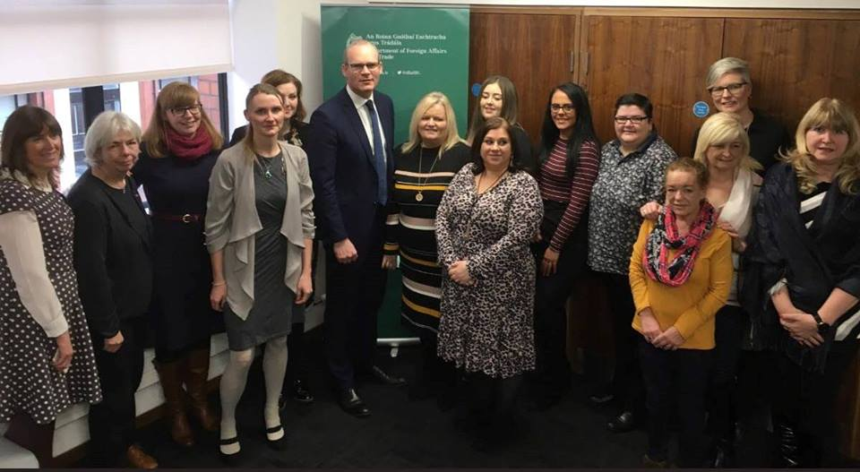

The “Peace Process
The Peace Process
According to Women
We created a Conversation Piece reflecting our journey…….

Reflection…….
Sharing the realities of living through the worst of the “troubles”.
The first section of our quilt interprets the chaos, the pain, the fear and the devastation of violent conflict on the lives of women and their families here.

Acknowledgement……
The participants shared how their lives had changed since the Good Friday/Belfast Agreement – acknowledging positive developments, the range of issues still awaiting implementation and still affecting communities adversely.

and Pushing for Progress……
Making plans to work together and keep our peace process and hopes for a truly inclusive, just and shared society at the forefront of all that we do.

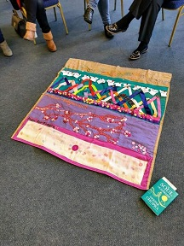

According to Women”

A complimentary project run in partnership with Community Dialogue is entitled
“The Peace Process According to Women”.

This project has, in a run up to the conference, been providing opportunities for women to reflect on the importance of women in all areas of peacebuilding here, where women were crucial in keeping societies together and keeping relationships alive across divides throughout the darkest days. It has also helped women to reflect on the realities of the past, acknowledge the importance of women in our peace process, understanding the journey we have all made from the past, to the ceasefires, peace talks and Good Friday/Belfast Agreement and the twenty- one years since and to dialogue and share ideas around moving forward together towards a truly shared and just society for all.

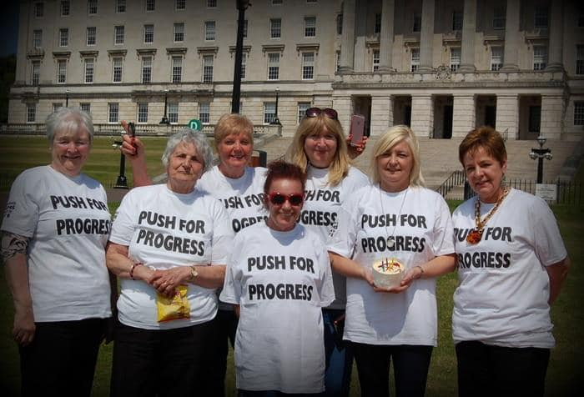

Community Conversation Series 2019
As part of the International Women’s Day 2019 events and in the run up to the 2019 Women’s Words Project annual conference, the Community Relations Council Small Grants Programme, funded a series of Community Conversations.
These were film and conversation workshops as we were delighted to have been able to show the Peace is Loud version of the acclaimed film, Wave Goodbye to Dinosaurs. This film documents the story of women organizing to elect two women to the Northern Ireland Peace Talks in May 1996, which two years later led to the Belfast/Good Friday Agreement.
Many members of Women’s Information Group, now WINI, were involved in this ground-breaking initiative.
The main aim of these roundtable events, was to reflect on the roles women played in keeping communities together through the worst years of the “troubles”, share experiences and stories from these turbulent times and then have a facilitated conversation around the issues it raises around women, peace, security, safety and participation today.
The participants were asked to prioritise the three most important issues around these themes, most affecting their lives and community cohesion today.

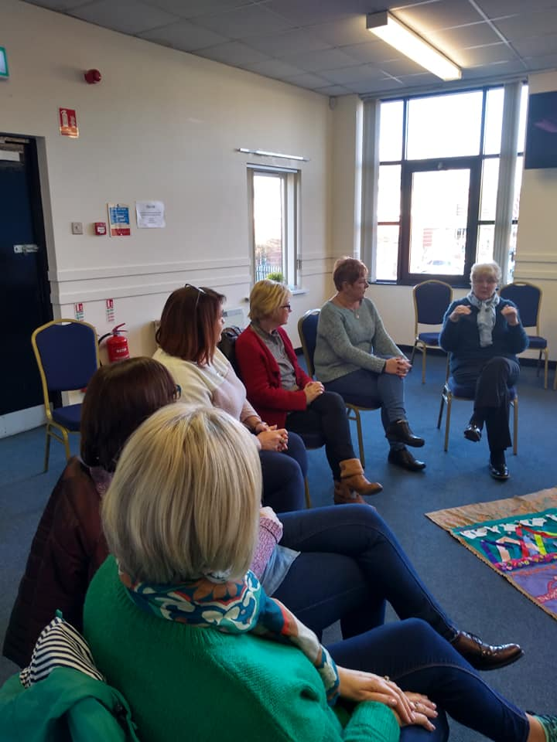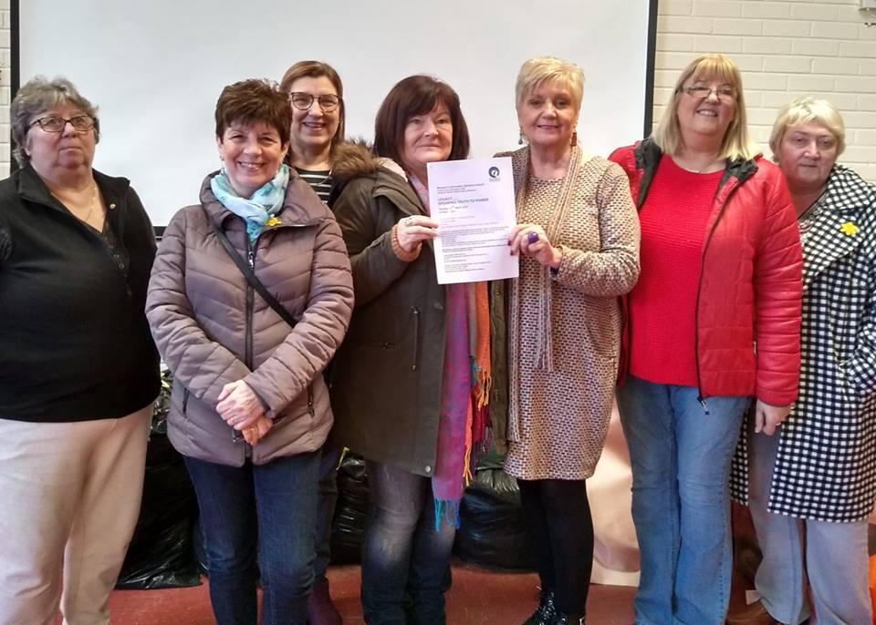
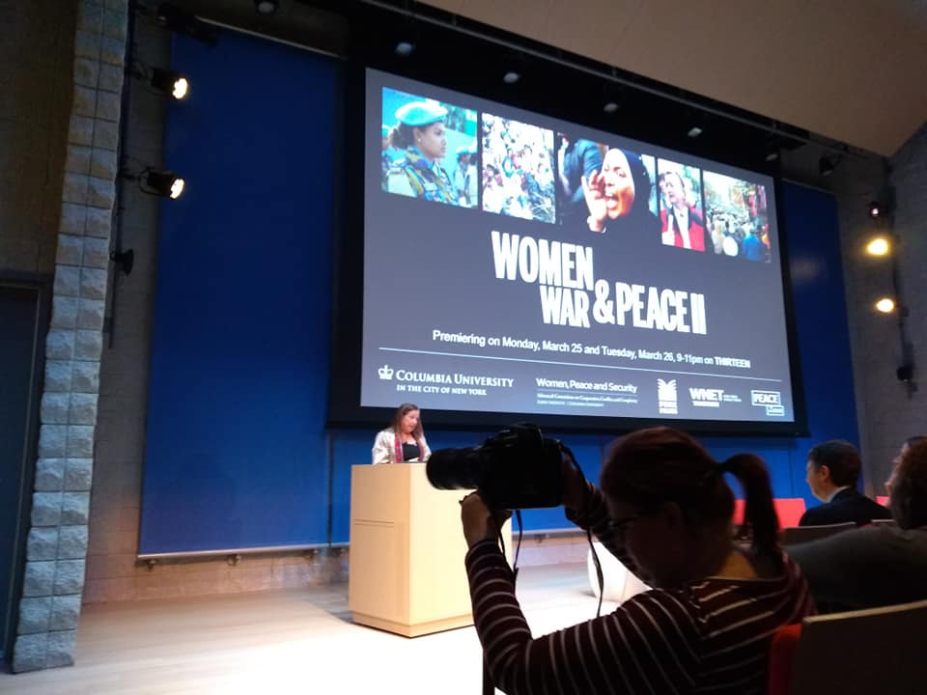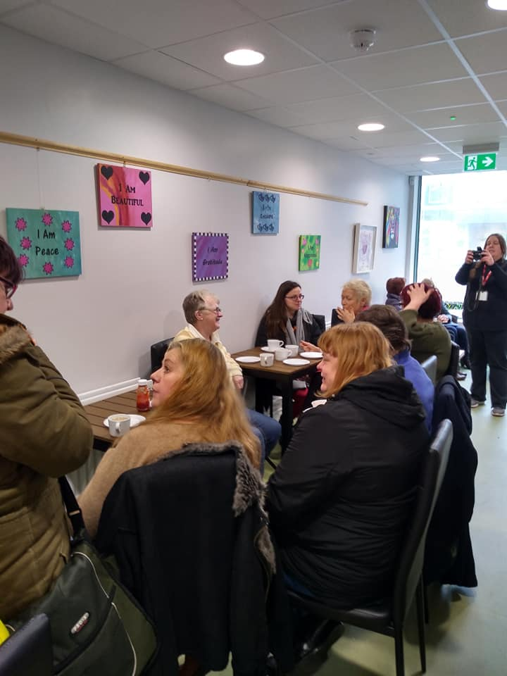

Below is a snapshot of the issues raised by women participants in our workshops.
“Universal Credit and welfare reform are causing so much hardship. It’s back to the workhouse era with poverty and foodbanks.”

“Domestic Violence –
Implement the legislation now
“Sectarianism and Racism. Where is our new shared society? Still a lot of fear around.”

“Huge affordable housing shortage.”

“More Law and Order”
“More women need to be involved in community policing initiatives and working with police. We want policing to work. We want law and order in our communities.”

“Still so much trauma. We need the legacy of the conflict to be properly addressed. Where are our new Legacy Institutions?”
It is scandalous that people so wronged are still trying to get proper support.

“Mental Health issues – we need a new stand alone facility. So many people suffering – a tragic legacy of the conflict. This has been acknowledged repeatedly and still we have piecemeal support.”

“Paramilitaries still controlling communities and recruiting young people. Many women live in fear. Gatekeeping and coercive control are rife.”

“Many equality issues still outstanding”
“Climate Change”
“More Working Class Representatives in Politics – Women still haven’t been recognised – It’s still a male dominated situation in Northern Ireland even if we do have women leaders but party politics means us and them and stalemate.”

“We need urgent action on drugs in our communities.”
“Implementing the Good Friday Agreement and getting our government up and running again with BREXIT Looming”

“Homelessness and people dying on our streets.” Why??
“Equal pay – women still paid less for doing many of the same jobs as men”

Our Phase 1 Finale Conference………
Legacy……….
Speaking Truth to Power
women sharing, women learning, women shifting, women shaping

This important conference was bringing the first phase of the Women’s Words Project to a close. It was important therefore, to bring to the tables, the issues affecting the positive well-being, safety and security of women as we continue to cultivate a peaceful, inclusive, just and shared future for all.
Our participants have been sharing experiences, highlighting the realities and thinking about solutions and ways forward to tackle some of the most difficult and contentious issues of our time. So often women have so much to bring to decision making tables and yet, their voices are often absent and unheard.

The focus of this conference therefore was –

Women Speaking Truth to Power

The legacy of decades of violent conflict lives with so many women every day and they are determined to work through the issues, bring back a spirit of generosity towards their neighbours across whatever divides and bring common sense, ease with difference and positive change to the heart of communities.

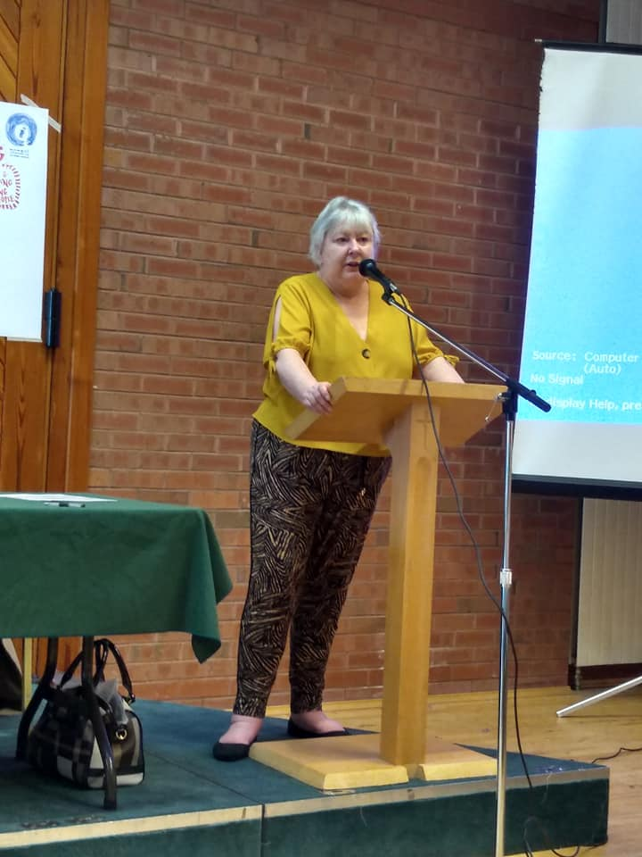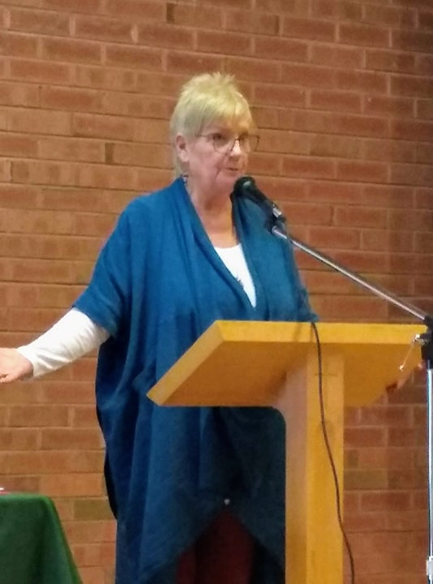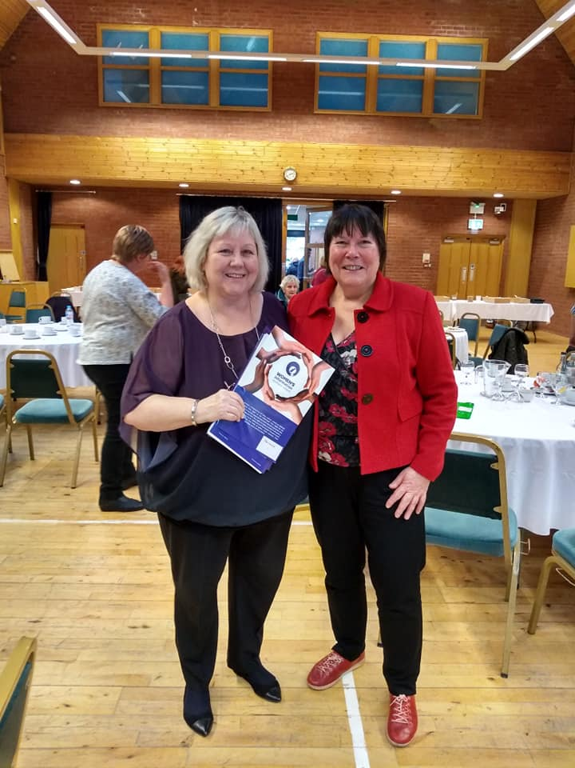

The Process……….

We had a full house of over 100 women at our conference. Participants came from many urban and rural areas across Northern Ireland.
We invited a range of speakers to make 10 minute focused presentations to the participants on issues which the women themselves had prioritized in our Community Conversations.
Sponsored by Community Dialogue, we had the talented Helen Gomez, a visual artist working with us. She brought the issues to life in a series of visual boards which were displayed and added to during the conference.

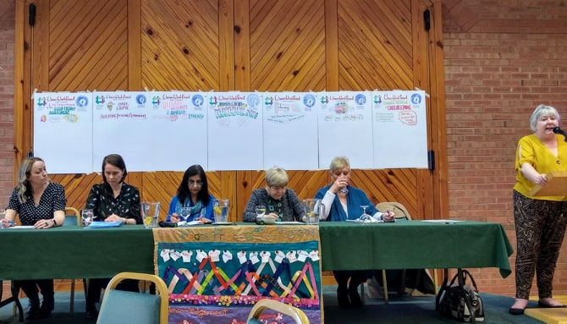
Speakers on the Issues….
Siobhan Harding
Research and Policy Officer
Women’s Support Network

Debbie Hammill
Project Manager
South Belfast Alternatives

Monica McWilliams
Member
Independent Reporting Commission

Mary Montague
Conflict Resolution Practitioner

Nisha Tandon
Founder and Director
ArtsEkta

Rachel Woods
Climate Change
Campaigner

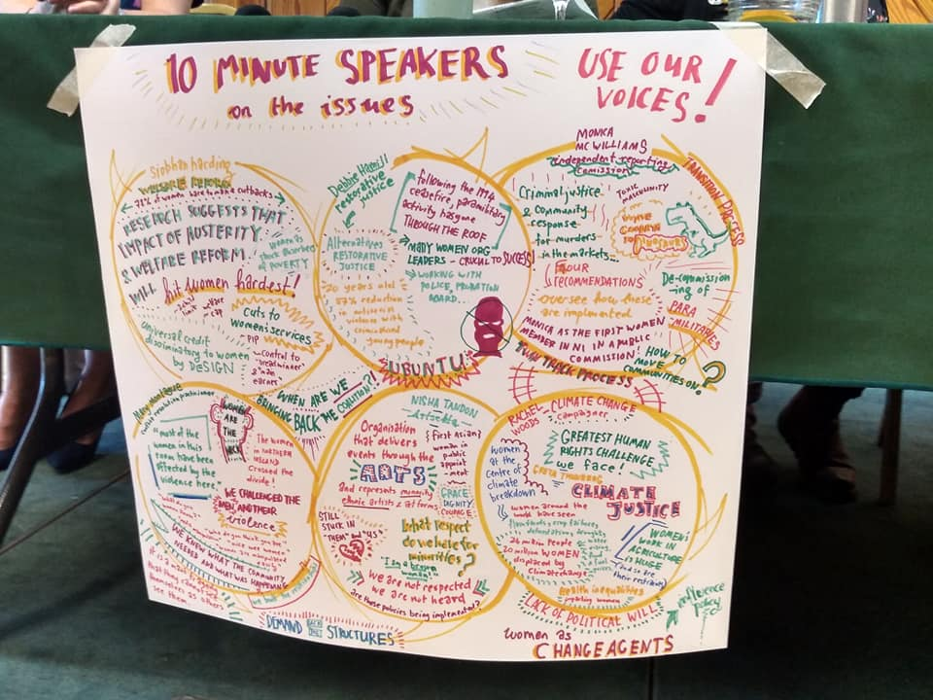

The Issues………….

The invited speakers were asked to give focused 10 minute inputs on the issues participants in the range of Community Conversation events had prioritized.

They were asked to “Speak Truth to Power” in their presentations.

Siobhan Harding

Issue – Welfare Reform and Austerity and the Impact on Women and Families
Siobhan is the Policy and Research Co-Ordinator for the Women’s Support Network and is responsible for consultations that are current and relevant to women. She was just completing a new piece of
Research on the effects of years of austerity and welfare reform on women and families. We were delighted to be the first group to hear about her initial findings and participants could relate to so much of what she was saying.

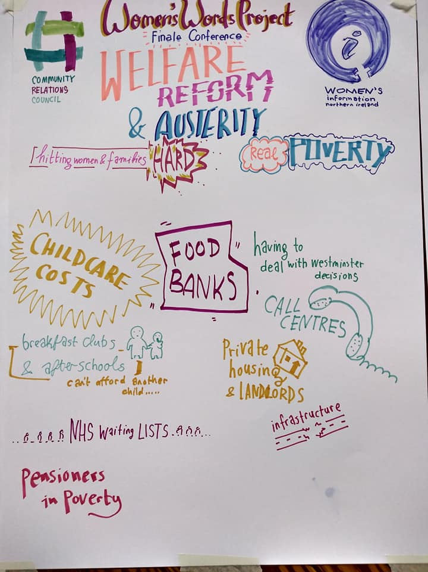

Debbie Hammill

Issue – Policing and the Community

Debbie is the Project Manager for South Belfast Alternatives (SBA) – a community based restorative justice organization that aims to promote and develop non-violent responses to issues of crime and anti-social behavior within Protestant/Loyalist areas. Debbie’s role is to support ex-combatants in their transition to community activism – positive engagement with communities through restorative practices – training programmes, one to one intensive support, family/victim/community support, mediation and inter-agency partnerships, particularly with the police service and other government agencies. Debbie and her team provide the same services as well as prevention/intervention programmes for disengaged, marginalized young people at risk of criminalization.

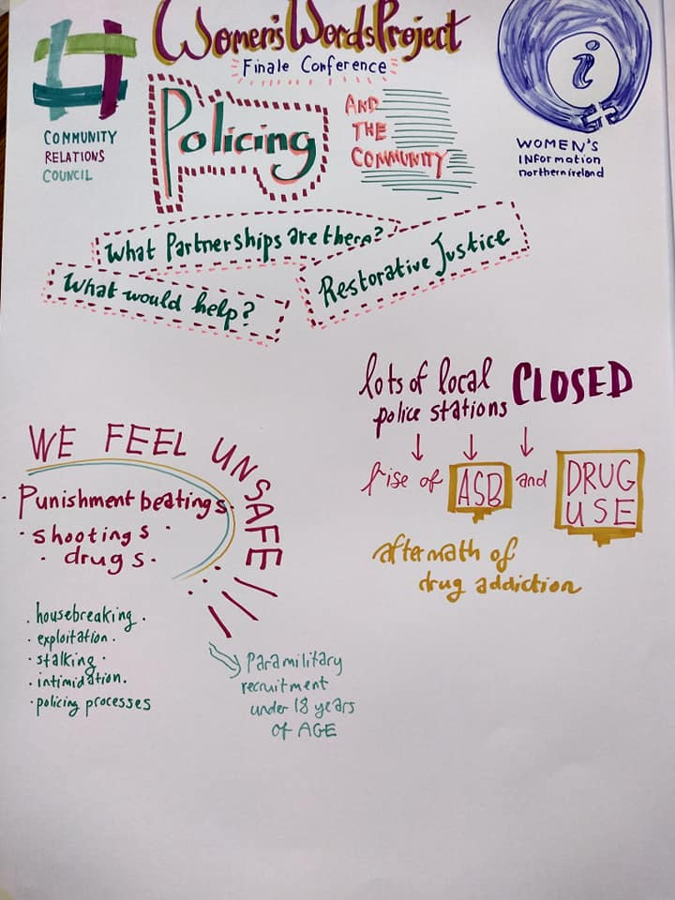

Participants raised very strongly the issues of policing at community level, the lack of resources and the need to make sure that the young people of today do not get involved in criminality. Women
spoke of the lack of women in communities being recognized contacts with the PSNI at partnership level.

Monica McWilliams

Issue - Coercive Control and Gatekeeping

Monica is Professor of Women’s Studies, based in the Transitional Justice Institute at the University of Ulster.
She gave an overview of ongoing work of the Independent Reporting Commission of which she is a member of the team of three. They IRC has been tasked, jointly by the UK Government and Government of Ireland, to support the ongoing development of long-term peace and stability in society and stable and inclusive government and promoting progress towards ending paramilitary activity connected with Northern Ireland. They are consulting widely with stakeholders including statutory agencies, law enforcement and civic society and will report on progress towards ending paramilitary activity.
Participants highlighted this issue as one of their main concerns. So many in working class communities feel silenced and fearful.

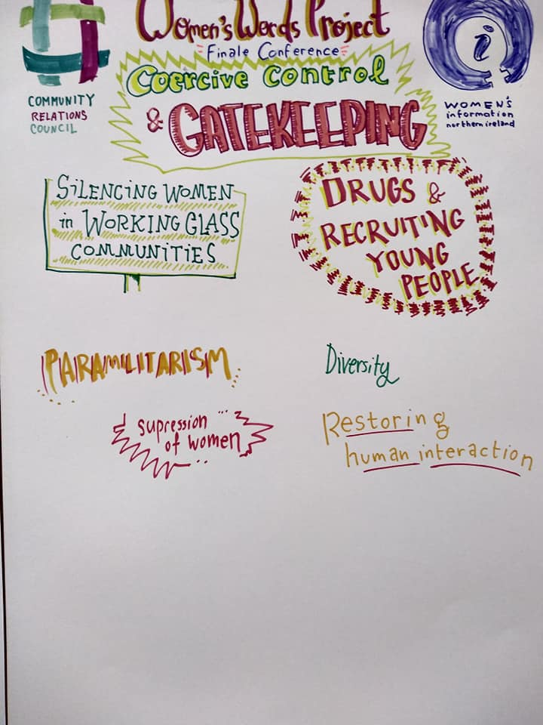

Mary Montague

Nisha Tandon

Issue – Women at the Heart of Peacebuilding

Mary has dedicated her life to building peace in Northern Ireland. She works in mediation, conflict resolution and restorative practice. Mary has worked extensively through the worst years of the conflict and since within and between grassroots working class communities helping to alleviate
tensions and restore calm in very volatile situations and help people from across the community divides to engage with one another and find commonality and pathways forward.

Nisha is the founder and Director of ArtsEkta – one of the only organisations on the island of Ireland promoting ethnic arts, culture and heritage. She is a founding member of “Stronger Together”, a collaboration of organisations working in the field of racial equality to support an integrated community development approach to tackling racism, promoting good relations, sharing and exchanging information, experience and knowledge.

Building trust, engaging in dialogue across communities, promoting equality and justice for all and finding ways through the current impasse which has resulted in our local Assembly and Executive collapsing were high on the agenda for women participating in our conference. Women know that their involvement is crucial to sustaining a credible and inclusive peaceful society yet they feel more and more excluded as time goes on. They are concerned at the number of hate crime incidents affecting families that have come from other countries over the years and enhance the diverse communities which are the reality for modern Northern Ireland society.
The fact that the Civic Forum, very much part of the GFA, has not been re-established, has widened the gap between women and decision and policy makers and means that many of these issues remain unaddressed and in some areas are worsening.

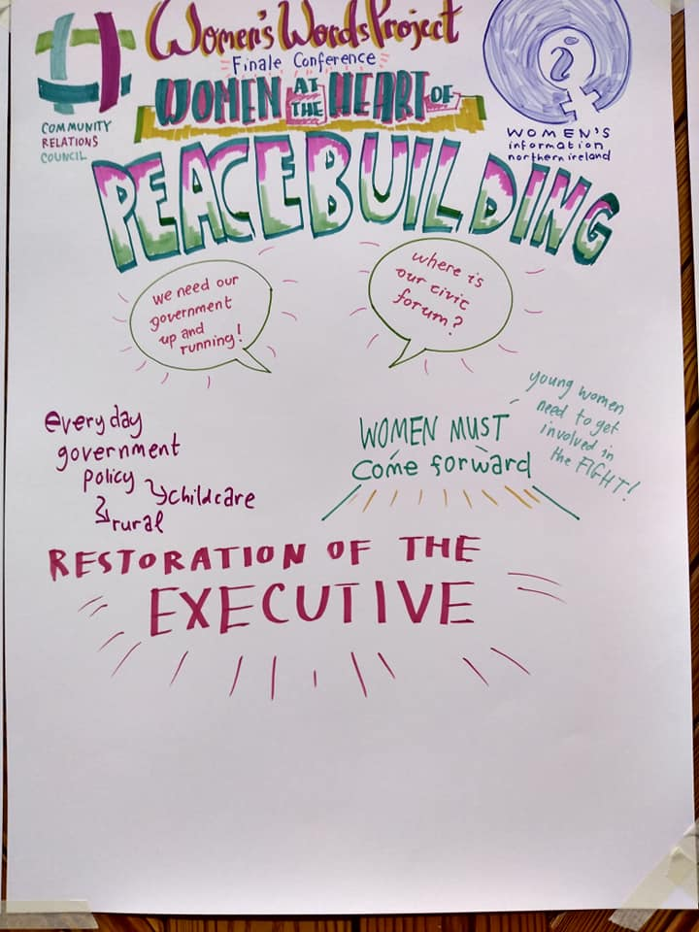

Rachel Woods

Issue – Climate Change
Rachel is the Green Party Councillor for Holywood and Clandeboye and Green Party Leader on Ards and North Down Council. She speaks regularly on the realities of climate change and the need to actively address the issues adversely affecting our planet and leading to a very real climate
emergency situation globally.

Rachel shared some of her thoughts on the main issues and how climate change is very much at the top of the agenda for many young people who are taking to the streets and demanding action now.

Participants agreed that one of the critical issues we must address is protecting our planet for future generations and taking seriously the very real emergencies in very poor countries around the world where weather changes, floods and droughts are leading to crops been washed away or failing completely and more and more people suffering unbearably.

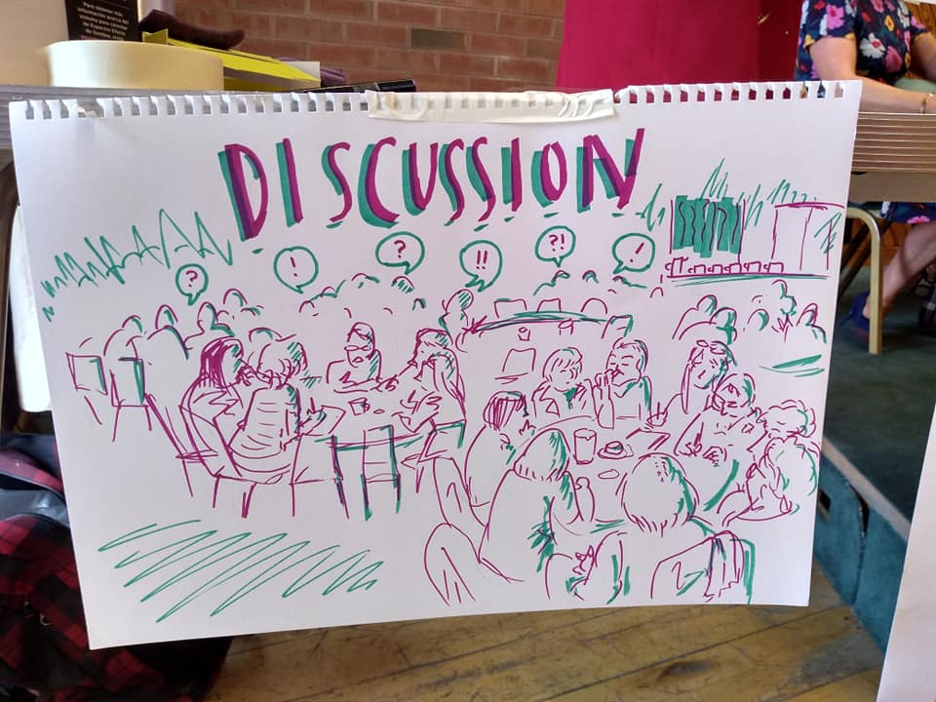

Creative Intervention

We were delighted to have Alice McCullough, a young performance poet from East Belfast to share some very thought provoking and heartfelt pieces during our conference.

Alice simply captivated the women attending. She has the amazing ability and talent to play with the boundaries between spoken word, comedy, storytelling and theatre. And at the same time raise the issues affecting peace and inclusivity, women and families today.

Firstly, Alice delved into the realities of “otherness” in Belfast in her acclaimed piece – Belfast, You’re Melting My Head”.

At the end of the conference she took to the podium again and raised the issues affecting women’s lives again in her new piece performed for International Women’s Day around rape

“We need to amplify the issues affecting our lives adversely and make sure that our voices are heard.” This is the cry from our participants and we can do that in so many ways.”

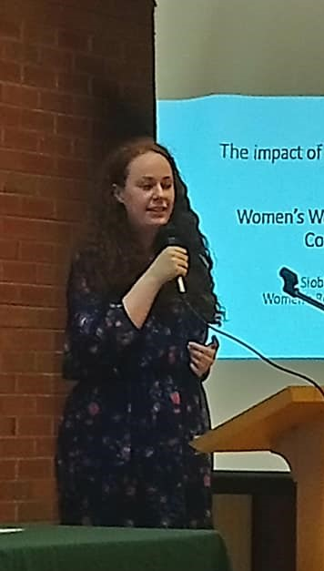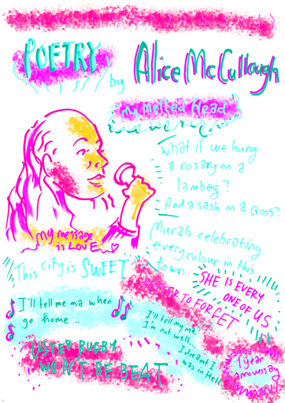

Responding to the Issues Raised
Women in Politics Panel
Chaired by Bronagh Hinds

The conference process ended with an opportunity for the participants to engage with female representatives of some of the main political parties in Northern Ireland.
The main theme of the day was – Legacy…Speaking Truth to Power.
Participants had spoken their truth in the series of pre-conference Community Conversations and heard from informed speakers on the main issues they were raising. They had responded to what the speakers had been saying and Bronagh Hinds of Democrashe summarized and collated the issues into three main concerns and these were put to the political representatives asking for responses as to how they were going to address these issues.

Representing the range of parties we had:

Claire Hanna, SDLP, Lauren Kerr, Ulster Unionist Party, Rachel Woods, Green Party, Linda Dillon, Sinn Fein, Michelle Guy, Alliance Party and Fiona Ferguson from People Before Profit. Apologies were received from Paula Bradley, DUP as she was recovering from illness.

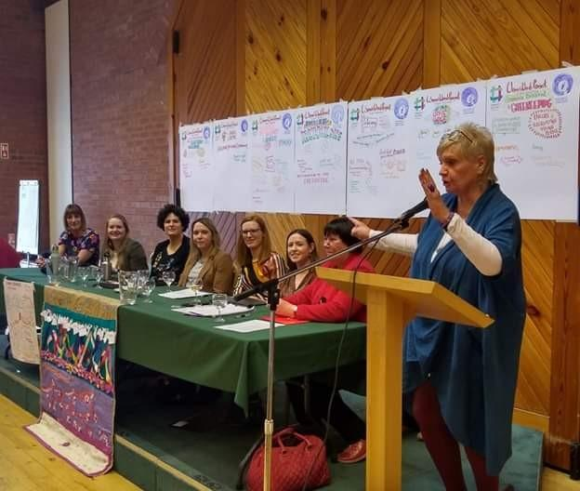

Bronagh summarized the process and explained that she had been gathering the main issues from the roundtable dialogues and they fitted into three main areas.

Social issues including welfare reform and austerity measures, poverty, homelessness, health and well being and lack of support for those most affected by the conflict.

Coercive control, gatekeeping, ongoing criminal paramilitary activity and recruiting and the effect this continues to have on women and their families in many working class areas both urban and rural in Northern Ireland.

The serious effects of the two year suspension of devolved government in Northern Ireland, the many areas of the Good Friday/Belfast Agreement still to be implemented and the very real fears around BREXIT and its effects on the lives and livelihoods of people living here and particularly in border areas and the threat to the new relationships and cross border co-operation enjoyed post the GFA.

Each of the political representatives acknowledged that the issues raised were extremely important ones, gave examples of how they were working to address them and their commitment to restoring devolution which was key to addressing serious issues of this kind.

The panel was made up of young, new generation committed people. The stalemate at Stormont continues as this report is being written and we await the outcome of a current talks process, chaired by the Secretary of State, Karen Bradley.

The participants and the panel welcomed the opportunity to participate in the conference and stressed the importance of this type of event to ensure that the voices of grassroots women are heard, taken seriously and valued as we move forward together and build the inclusive, united, peaceful society we can all call home.

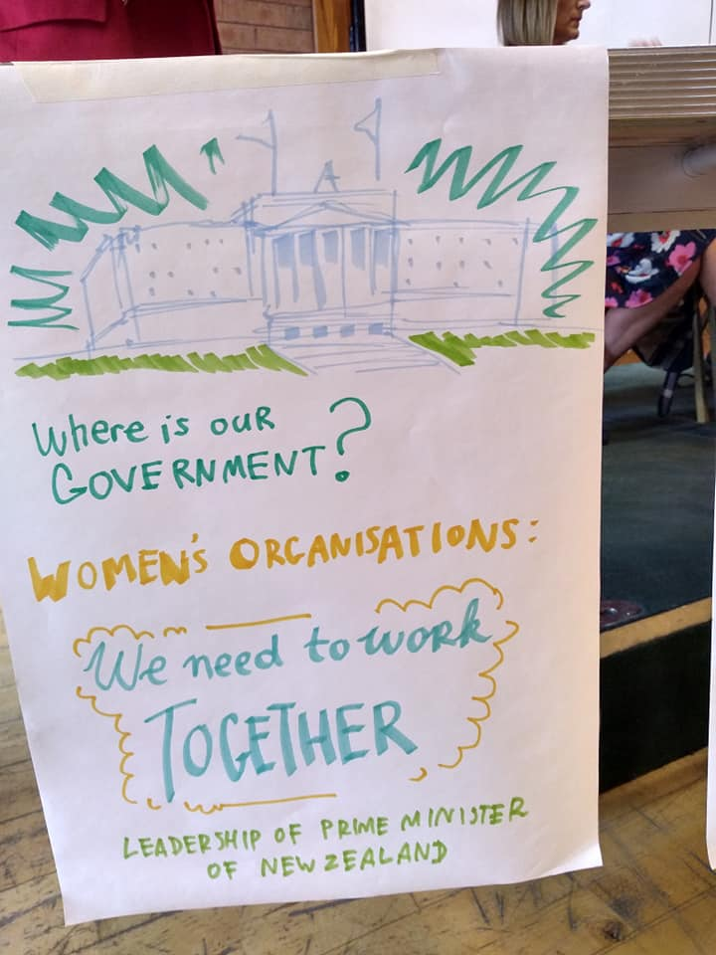

Our RAP – written as part of our
Peace Process According to Women project by Anne Carr

Now listen guys
It’s women here
And we’re not about to disappear.
We’ve lived those troubles through thick and thin
Worn those t-shirts
They’re in the bin.
Years of worry fear and pain
Bloody streets and bullet rain.

We packed those boxes, prison bound
Fed the kids on just a few pound
Cried with mothers felled through grief
Hugging headstones in disbelief

And news that raised a grain of hope –
What! Ceasefires, talks and peace
Can we cope?

We know the price of hatred bred
So Agreement – what is it it said ?
Equality, its fair and just
Not more for you and less for us
A Civic forum, we’d have a voice
And those in power would hear our choice

Poverty’s ill attacked head on
Discrimination – making sure it’s gone
Integration – homes and schools
Parity of esteem
The golden rule!
Now twenty years has whittled away
The big white house is mothballed and grey
A new generation of mums and dads
Are scratching their heads and going mad
Where is this peace a promise made
To work together not to fade ?

It seems to us the time has come
For women strong to raise it some
We want what’s best for one and all
Our kids to prosper not to fall
Victim to some drug fueled lord
Where suicide becomes the sword
So what we want is peace not war
And women to be at the fore
To mediate and plan and care
And rid the streets of all nightmares
To shift and shake and shape and meet
Each other fairly
So let’s go get
Informed and ready
Is it our turn yet ?

Oh yes it is !

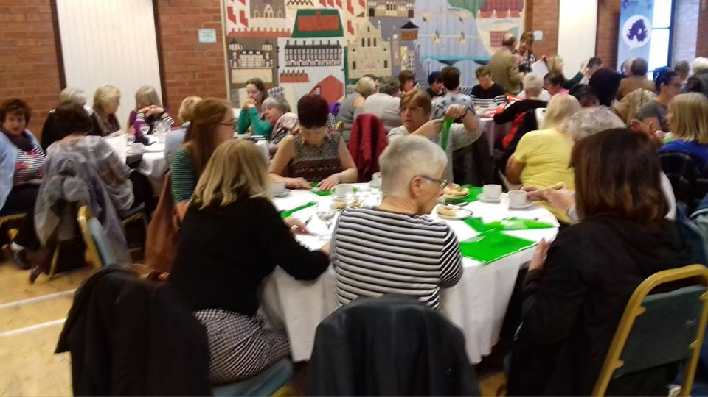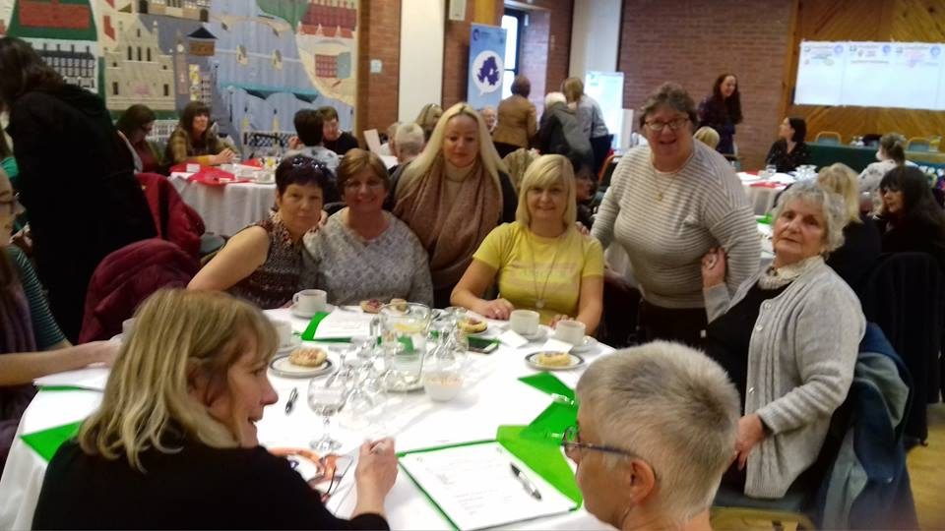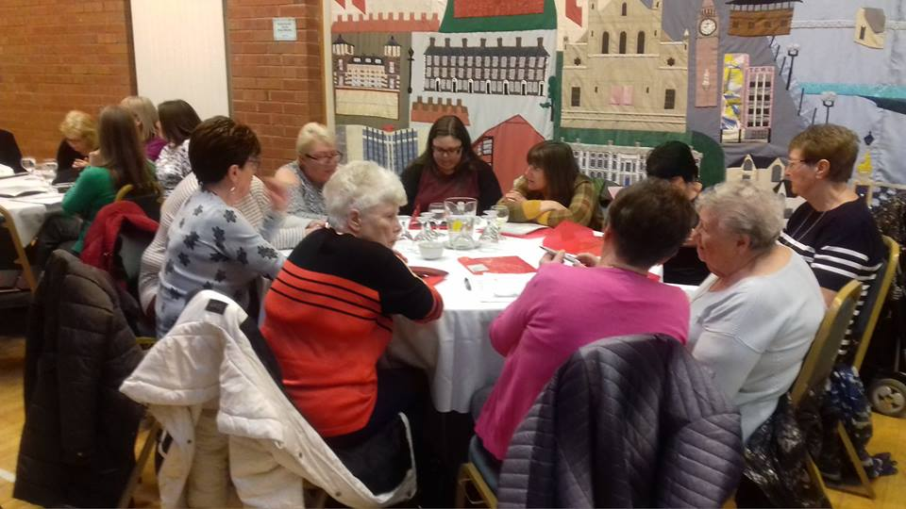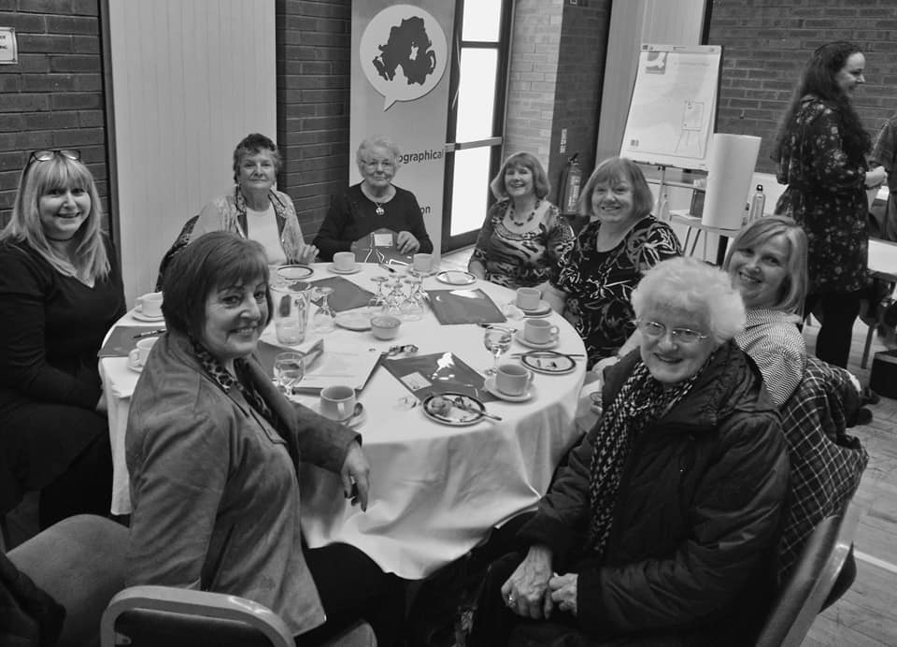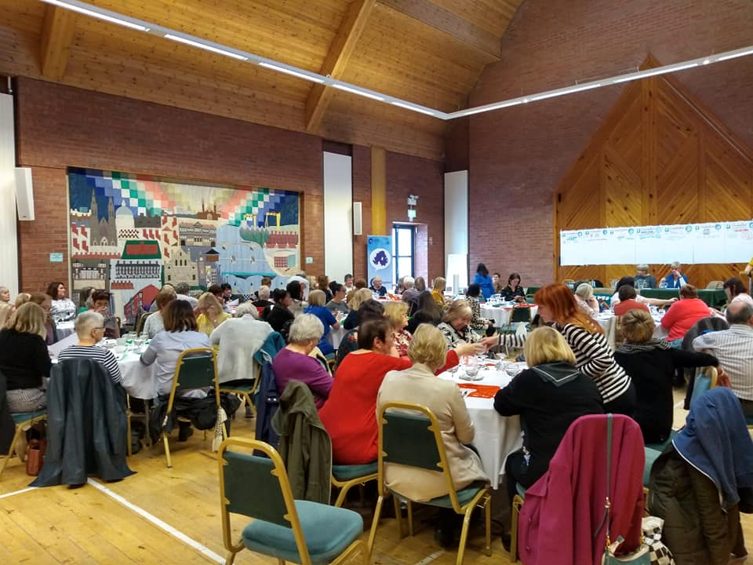

Amplifying the Voices of Women in the Room……..

Without doubt we need more opportunities for women to come together and share experiences, learn from informed sources and have their opinions taken seriously and valued. Thank you to all our participants throughout Phase I of our project.

We need to build consensus and amplify these important voices throughout the decision making, policy creating and political worlds. Phase II of our Women’s Words Project intends to do just that.

Below are some of the comments captured on the day…….
Universal Credit has caused so much confusion. Women are struggling to make ends meet and cannot understand these systems.
Domestic violence and coercive control will only get worse!
Food Banks – demoralizing and degrading. Judgements are being made. Conflicting advice from different agencies. Leading to homelessness and despair.
What sort of society employs people on zero-hour contracts, short term work it is women who are most affected

Thoughts on what the range of speakers contributed
So much female talent and experience in one room – we need so much more of this to help us inspire and motivate one another.
We need to change the language from Cross Community to Shared Community.

Women are central to peace building and moving our society on.
They can compromise and work together for the good of all.
Women have so much to say and positive ideas to contribute yet so often are
not listened to.
We are still dealing with the same issues thirty years on. Things have improved but we are still fighting!

LBGT people, ethnic minority groups can still be treated so badly. So unfair .in a m

Where is our Bill of Rights ?
Gatekeeping is very real.
We need more work to empower women in communities. Our stories should be heard.
Very brave even today to say what religion you are and background you come from. There is still so much fear around and depending where you are.
There is still a lot of control over women, what they do and what they say. Coercive control is alive and kicking in many areas and women are afraid for their children and families so don’t speak out.

Employment
Too much menial and low paid work.
Zero hours contracts, short termism.
Very real working poor.
The gender pay gap must be addressed.
Still sexual harassment in employment – men wanting to dominate.
The rape and plunder of areas like the Shankill and East Belfast
has led to so few opportunities for employment. The traditional industries have gone and there is nothing to replace them.
Rural Women Have Issues Too
Often feel very isolated. Lack of support services for women, youth services, poor transport .
There are drug issues in all schools. We need more connections with our young people. Food banks now too – never before – working poor.
Bigger gap between the rich and poor and so many other issues progress from poverty.
We want to be involved. We need many more opportunities to have our say and work with women on issues that affect us all.

Mental Health Issues
PTSD in communities as a result of the troubles.
Still so much grief and unanswered questions.
Domestic violence legislation on hold.
Women deal with all the issues families are struggling with.
Stress and anxiety are rife.
Drugs are often a coping strategy and seen as a way of making money.
What are the most important issues faced by women in your community today ?
Collapse of Stormont
We need accountable and transparent government and compromise to lead the way. A move to mature politics!
We need to demand that political structures are reinstated with all the spirit of the Good Friday Agreement.
We don’t need sectarian politics.
BREXIT has been so divisive.
We need politics for the common good.

Empower Women
Empower Communities
In recent years the voices of women from grassroots communities, urban and rural have been silenced.
We need to be heard and our issues and ideas taken seriously.
Community Safety and Policing
Women want to live in a safe environment without fear of intimidation, abuse or exploitation. There is an increase in tensions and fear now – elderly people are frightened to live on their own, house breaking, crime has increased. Many women feel more vulnerable.
We need to improve community policing and get more women involved.
Ongoing conflict is being driven by men and dealt with by women.

Childcare
So many issues to be addressed.
So disadvantaged here.
Even worse in rural areas.
Fear of losing childcare benefits excludes women from opportunities to work or train for well paid employment.
Fewer number of childcare places.
Loss of ESA or grants
If parents work.
Climate Change
Women can take the lead. We can boycott all plastic covered products in supermarkets.
We can educate ourselves and stand together with the young people taking a stand.
Climate change is real!
Lack of Education
So many barriers to women accessing education including access, childcare costs, austerity, lack of knowledge about what support and benefits are available and generally a lack of confidence.
Older women struggle with technology.
There is no encouragement for women to become professionally qualified. So many have caring responsibilities.

