Summary Record

Together: Building a United Community
Engagement Forum

Tuesday, 20 September 2016

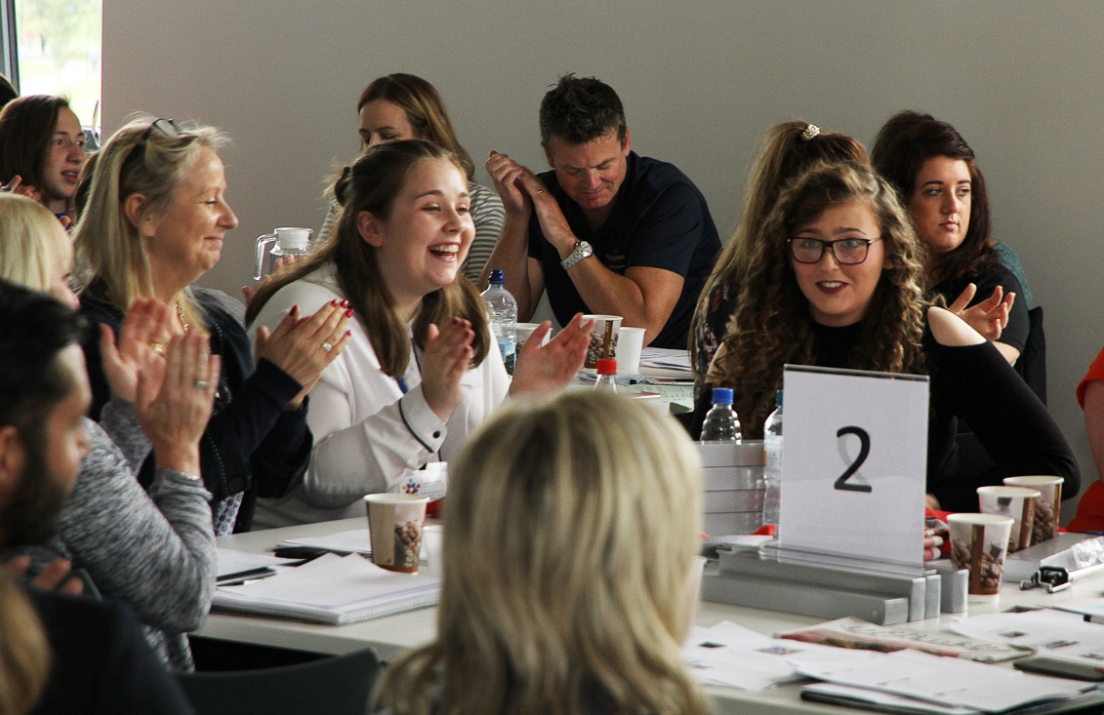

On 20 September 2016, the Executive Office (TEO) and over 175 community practitioners, policymakers and academics gathered in The Junction, Dungannon for the third meeting of the Together: Building a United Community Engagement Forum. The event focused on the T:BUC priority of Our Children and Young People regarding challenges and opportunities “to continue to improve attitudes amongst our young people and to build a community where they can play a full and active role in building good relations”

Mark Browne, Strategic Policy, Equality and Good Relations Director and T:BUC Engagement Forum Chair
Mark welcomed delegates to the third Forum event which was taking place during a very busy Community Relations and Cultural Awareness Week. He welcomed the two Junior Ministers, thanked them for attending all three Forum events and invited them to the floor.

Junior Minister Alastair Ross MLA & Junior Minister Megan Fearon MLA
The Junior Ministers praised the venue as a landmark community building and noted the conference as the keynote event during this year’s Community Relations and Cultural Awareness Week. They reminded delegates that a third of our population is under the age of 25 and stressed the importance of building good relations amongst our children and young people to help equip them to build a more peaceful, multicultural and tolerant society. The Ministers also spoke of the importance of engaging children and young people in the delivery of the T:BUC objectives and highlighted the benefits of T:BUC programmes including summer camps, shared housing and shared education. They also praised the inclusive process around the co-design approach and the engagement of young people from different cultures.
Mark Browne, The Executive Office
Mark informed delegates that a summary record from the June meeting was available on the Community Relations Council (CRC) website. He provided the following update:

Fresh Start Agreement - the Executive’s Fresh Start Agreement (FSA) commits to ensuring the full implementation of the T:BUC Strategy. Beyond that, it commits to continuing efforts to eradicate sectarianism in all its forms. Over the next five years, the FSA provides £60M to support the implementation of the T:BUC strategy alongside £50M to support actions to combat paramilitarism. The Commission on Flags, Identity, Culture and Tradition has been established under the joint chairmanship of Dr. Dominic Bryan and Neville Armstrong; it is drawing up plans for engagement with stakeholders across the community and is keen to ensure the inclusion of young people. The FSA also recognises the significance of increasing the participation and influence of women in community development and commits to developing a cross departmental programme to prevent vulnerable young people from being drawn into paramilitary activity. Plans are currently being developed by departments to take forward action in these areas.
Programme for Government Framework 2016-21- consultation on the PfG outcomes and indicators took place over the summer and will help inform the development of draft delivery plans which will be published for consultation alongside a draft PfG in October.
Shared Neighbourhood Programme - two shared neighbourhood developments have been completed with a further eight under construction in various locations.
Urban Villages- five urban villages have been established. Engagement with local residents, community organisations and key stakeholders has been key to the development of shared priorities within strategic frameworks for each area. The Urban Village Programme has provided £1M for capital projects with a planned capital investment of £2.6M to support 28 projects and £1.6M of revenue projects to support community activities.

Interface barriers - the number of interface barriers has reduced from 54 to 50 with sections of other structures removed and action plans being developed for 24 other structures. The first NIHE peace wall was removed recently on the Crumlin Road.
Children and Young People
- The Cross-community Youth Sports Programme piloted in the Lower Falls and Village areas of Belfast last year included midnight street soccer, encouraging female participation in sport and a sports and good relations roadshow aimed at children aged 11-14.
- Promoting Good Relations Through Sport Project distributed 200 T:BUC branded sports bags and equipment to a range of community sports clubs and organisations. TEO is working with the Department for Communities to deliver this cross-community youth sports programme in two Urban Village areas and also in Lisnaskea.
- Summer camps - 101 summer camps were delivered in 2015 with an investment of £1.2M committed. 103 summer camps are anticipated during 2016 catering for over 4,500 young people.
- Shared education - The first phase of the Strule shared education campus in Omagh was launched last week with the opening of the new buildings for Arvalee Special School and Resource Centre. The economic appraisal for Limavady and Ballycastle Shared Education Campus has been approved, and the economic appraisal for the Moy Campus is under consideration. Project boards have been established for Brookeborough Campus and the Duneane and Moneynick campuses.
Racial Equality - The Racial Equality Strategy 2015 - 2025 - was agreed by the Executive in December 2015. The 22 member Racial Equality Sub-group held its first meeting earlier in September 2016 which the First and Deputy First Minister and Junior Ministers attended. A racial equality champion has been appointed in each of the new departments. TEO continues to work with the Department for Communities and the voluntary and community sector to resettle refugees under the Syrian Vulnerable Persons Relocation schemes and have welcomed and resettled four groups in Belfast, Derry/Londonderry and the Antrim/Banbridge/Craigavon council areas. More groups are set to arrive on a phased basis with a focus on supporting their long-term integration into our society. A Refugee Integration Strategy is also being developed to provide a wider framework to ensure the smooth transition from being a refugee to building a new life here.
Dr. Dirk Schubotz, YLT Director, ARK, Queens University
Dirk’s presentation addressed the issue of young people’s attitudes to community relations, cross-community contact and their sense of belonging.
Dirk predominantly used Young Life and Times (YLT) survey time series data but he also incorporated findings from the Northern Ireland Life and Times (NILT) survey to make comparisons between 16 year olds’ experiences and those of adults in Northern Ireland.
After giving some background information about YLT and NILT, Dirk reflected on the finding that attitudes to community relations among 16 year olds have not changed significantly since 2003 (the first YLT survey). Whilst significant events such as flag protests and the breakdown of power-sharing arrangements had an impact on young people’s perception of community relations and their sense of optimism; overall 16 year olds in 2003 had very similar attitudes to 16 year olds in the most recent YLT survey in 2015.
Interestingly the YLT and NILT data shows that, despite 16 year olds’ very clearly expressed perception - documented in numerous comments received every year - young people hold less negative views about community relations than their adult counterparts, and that it is the adults who are responsible for passing on negative stereotypes.
Dirk then provided evidence that preferences for shared workplaces, neighbourhoods and schools were also similar in 2003 and 2015. Whilst the majority of adults and young people prefer mixed religion environments, during the 12 year period from 2003-15, there has only been a statistically insignificant increase in mixed religion environment preferences. Furthermore, it is again the adults and not the young people who are more likely to prefer religious mixing.
There were, however, significant changes in the level of contact 16 year olds have with people from minority ethnic backgrounds and the number of friends who have a different ethnic background. The vast majority of 16 year olds have very positive attitudes to minority ethnic groups.
The last part of Dirk’s presentation dealt with education in schools, community relations and diversity (CRED) and young people’s rights. The YLT data shows clear evidence that CRED education is very strongly related to more positive views about others. There is also a very strong relationship between rights education and a sense of belonging.
Very few young people expressed a very strong sense of influence on decision making in their neighbourhoods and in Northern Ireland, however the YLT evidence suggests that being educated about rights in school increases the sense of belonging and sense of influence, as well as the willingness to speak up about rights. If the aim is to include young people more in matters that affect them, then this should be taken as encouragement to do so. The YLT data suggests that the vast majority of 16-year olds think young people can potentially, and already do, contribute to the improvement of community relations in Northern Ireland.
Ciara Gaffney & Courtney Girvan, NEET Strategy Forum
Ciara described the Not in Education, Employment or Training (NEET) Strategy Forum as a 90 strong member organisation. It works with many of the 24,000 16 to 24 year olds experiencing difficulties in obtaining or maintaining education, employment or training. She explained that the overall unemployment rate for all 16-24 year olds in July 2016 was 5.6% however the youth unemployment rate was 13% which is over twice the overall NI unemployment rate.

Ciara outlined some of the difficulties that affect the opportunities young people have and contribute to difficulties in trying to access opportunities which can lead to a lack of hope and mental health and general wellbeing problems. Many of these problems are outside the young person’s control e.g. bad school experiences; problems at home; lack of support; language barriers for newcomers etc and include living in interface areas and areas with a strong paramilitary presence.
Courtney talked about how the NEET Strategy Forum works with young people to identify solutions to barriers and enables them to get their voice heard at a policy and programme design level.
Ciara and Courtney discussed their involvement in the T:BUC Summer Camps co-design process. NEET Strategy Forum representatives were invited to attend a workshop in December 2014 as experienced experts to begin a conversation about good relations. They explored the importance of summer camps in a segregated society and highlighted the need to break down barriers for all young people so they can work, travel and socialise freely in Northern Ireland. They also examined the skills and qualities required by those delivering these programmes.
Courtney outlined how they developed an outcomes based approach for young people which included building friendships, getting to know new people from different backgrounds, developing an understanding of others, learning from one another and, most importantly, ‘having a bit of craic’. The group agreed to become more involved in the co-design process and established a T:BUC working group within the NEET Youth Forum that focused on contributing to the co-design process.
They explored what a united community could look like with department officials and produced a report to open it up to other young people including the NI Youth Forum. Their ideas were fed into the ‘oldies meeting’ to help inform their discussion. The young people described this process as intergenerational work.
The speakers concluded that, in order to achieve a peaceful society and a united community, young people have to be genuinely engaged, including and beyond the traditional green and orange focus. Co-design is an effective method of genuine youth participation as it uses young people’s expertise to shape and design programmes, thus producing better outcomes for young people.
The speakers concluded that this framework of engagement and co-design should be established as a regular occurrence to show the Executive is serious about creating a united community which focuses on the inclusion of all young people covering all of Section 75 categories. The NEET youth forum sent out the challenge to the Executive Office that in creating a united community it has to find ways to include the voice of young people.
Tim O’Malley, Community Development Manager, Clanmil Housing
Alicia Whyte-McGivern from Holy Rosary Primary School
Sophia Willis-Reddick from Forge Integrated Primary School

Tim O’Malley outlined Clanmil Housing’s commitment to promoting new Shared Neighbourhoods as opportunities for people to live in mixed areas. He explained that this provides an important choice for people who want to live in a neighbourhood with people from diverse backgrounds and traditions.
Tim quoted statistics from the Northern Ireland Life and Times survey in 2015 where 71% of people stated that they would prefer to live in mixed religion neighbourhoods. Despite this, according to research by the Northern Ireland Housing Executive, 90% of social homes are single identity. Mr O’Malley explained that this is a hugely important issue in terms of a stable and peaceful society in Northern Ireland. He further explained that Clanmil’s commitment to promoting new Shared Neighbourhoods is driven by real life situations involving people who desperately want to bring up their families in mixed areas.
Tim went on to explain that Clanmil is committed to understanding how sharing can work in each area where a new Shared Neighbourhood is planned. He gave an overview of the “A River Crossing” project which Clanmil and Partisan Productions developed in partnership with three schools in South Belfast - Forge Integrated Primary School, Holy Rosary and Rosetta Primary School - the aim of the project was to help children explore what sharing meant to them and use their aspirations for the future to create a drama about diversity and change.
One of the participants, Alicia Whyte-McGivern from Holy Rosary Primary School, outlined her experience of the project and said she really enjoyed being involved. She particularly liked meeting new people from different backgrounds. Alicia described how her experience helped her develop an understanding that she had a lot in common with the other children and affirmed the importance of having shared experiences with people from other backgrounds. Furthermore, being able to choose an art form to focus on made the project much more enjoyable and gave her the scope to be more creative.
Sophia Willis-Reddick from Forge Integrated Primary School explained that through the project she met a lot of new people and really enjoyed being a part of the process of writing the script. In addition, she enjoyed meeting and learning about other people and enjoyed the collaboration of different views and ideas in the development of the project and production. She valued the importance of learning about other people and other religions.
Tim explained how the experiences and legacy of the children’s work will help develop and inform the ethos of the new Shared Neighbourhood in their area.

Denise Wright, South Belfast Round Table and Ghaith Hanna, Syrian Refugee
Denise Wright coordinates the Refugee and Asylum Forum. She described the scale of the humanitarian crisis in Syria -13.5 million people need assistance in Syria and there are 4.59 million refugees in surrounding countries including 2.5 million children and young people. Having visited Syrian refugee camps just over the border in Jordan she has seen the need first hand and witnessed the level of security checks which take place before any family is cleared to take part in the scheme. Those who are eligible to come are deemed to be particularly vulnerable e.g. women and children at risk, people with severe medical needs or those who have been victims of torture or violence.

She described how the UK government announced the Syrian Vulnerable Persons Scheme in September 2015 in response to the crisis and explained that the NI Executive then committed to bringing some refugees to Northern Ireland. To date, NI has relocated 221 Syrian refugees and plans to take two more groups before the end of the year. Those who arrive here are met at the airport by Red Cross staff and are brought to a welcome centre where they have some days to familiarise themselves before moving into their new homes which are in private rented accommodation. They are supported by workers from Barnardos and Extern who work with them to access services and become independent.

Young people who come here face a number of challenges including interrupted education, difficulties in accessing training or employment and a lack of English, all of which can be a great barrier to integration. Fitting into schools or communities where people already have strong friendships can prove difficult and the real question here for young people is how do they engage, how do they get their voice heard and how do they acquire enough information to enable a sense of belonging.
Ghaith Hanna who arrived in NI under the scheme in December 2015 with no English at all spoke of his experience. He thanked everyone for receiving the families. He was initially very surprised to hear he was coming to NI but he was very happy to be coming to a safe country. He knew that that NI had previously been a country in conflict but that it is now ‘safe and happy’. Ghaith spoke of how important it is for him to learn English explaining that he attends Belfast Metropolitan College every day for lessons – he has only been going there for two weeks. He said that that the people are the best thing but that he doesn’t enjoy the weather. He hopes to open a hairdressing shop in the future.
Workshop feedback
The voice of young people at the conference was wholeheartedly welcomed. A request was made for young people to be supported to design and lead a future T:BUC Engagement Forum to allow for more in-depth conversation about their ideas on how to enhance T:BUC.

Providing safe spaces where young people can properly share, talk and learn about different cultures and faiths and using creative approaches like bouldering, biking and residentials were considered to be effective ways of engaging young people. Experienced and trusted youth leaders are essential for the delivery of programmes and detached youth workers can help to engage ‘hard to reach’ young people.
Although it was acknowledged that engagement could be strengthened through good existing (but diminishing) youth structures, there is also a need to train good peer educators and facilitators in peacebuilding. It was further suggested that existing good practice should to be mapped properly to help share learning and identify gaps in provision.
The co-design process was hailed as a useful methodology as it offers a variety of approaches to meet different circumstances and uses partnership as a ‘two-way street’ learning between young people and adults and vice versa. Young people also found the type of community and race relations activities offered in programmes such as the summer camps, more interesting and meaningful than those offered in school.
It was noted that the school system can create division and support for a fully-fledged integrated schooling system to match the improving attitudinal change seen at local level is needed. This would require equipping schools with the necessary skills and resources; motivating teachers; embedding the learning to ensure long term sustainability and creating the conditions to support young people in their homes and communities. The Scottish model was cited as good practice alongside the need to bring CRED back to its full potential with adequate resources.
T:BUC interventions were thought to generally work, however, the need to create a critical mass of young people whose attitudinal change and influence on policy and practice, takes the form of ‘a snowball rolling down the hill’ was outlined. This will require a long term; big scale; joined up; co-design plan with clear outcomes and in which young people are included as a key group. A plan such as this must include programmes to address young people’s employability, good relations and personal development needs.
More generally, the important work of addressing the overall root cause of social deprivation, disempowerment and segregation when focusing on issues such as flags, emblems, bonfires and cultural identity was identified. The ongoing issue of paramilitary control and recruitment of young people was also raised as a serious problem. More positive leadership in peacebuilding by politicians, parents, community leaders, teachers and other influencers was called for to provide young people with good peacebuilding role models. All of this requires longer term society-wide engagement in good relations and more effective partnership within and between government and grassroots practitioners.
Creating champions for change within government departments was welcomed as this would help to ensure the needs and voice of young people were heard, inspire and enable them to have an active say in policy development and delivery and help connect them to service providers.
The issues and needs of ethnic minority youth was identified as an area that needed more in-depth research along with myth busting facts and figures to dispel wrong perceptions and untruths. This will require the necessary resources and support to develop and deliver approaches to help young people from across all cultures to have a better understanding about our multicultural society and engage them in good relations activities.
Additional efforts to re-engage ‘hard to reach’ young people who may be disengaged from education and/or employment was stressed. There was also a plea for projects such as the NEET Youth Forum, Peace Players International, A River Crossing, Community Relations in Schools and the Strategic Migration Partnership to be safeguarded, resourced and promoted as they all play a critical role in moving from fire-fighting to sustained interventions for young people in urban and rural areas.

To view presentations and workshop information click here

