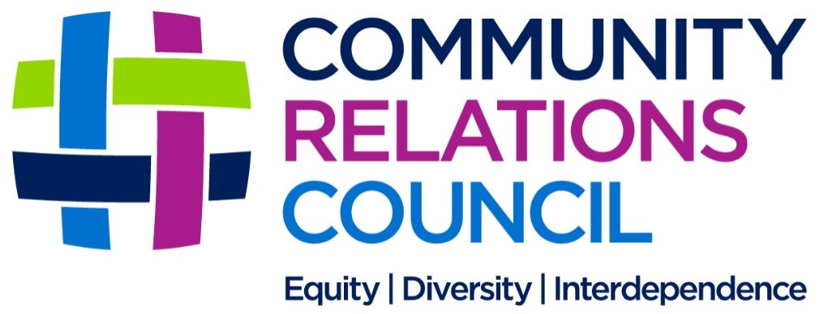

Good Relations Award 2020/21

Nomination Form

The Community Relations Council are inviting nominations for the 2020/2021 Good Relations Award.
Nominations close at 12 noon on Friday 29th January 2021. Late nominations cannot be accepted.

Our preference is to receive your completed Nomination Form by email to info@nicrc.org.uk
Or by post to
NICRC
Good Relations Awards
2nd Floor, Equality House
7-9 Shaftesbury Square
Belfast
BT2 7DB

Self-nominations are not permitted. Staff and Board Members of the Community Relations Council, and their family members, are ineligible although they may nominate others.

We have updated our Privacy Notice to reflect changes we've made that strengthen your privacy rights. This is part of the Community Relations Council’s commitment to how we use your data and keep it safe. We have included changes to address the new standards introduced by the data protection law known as the General Data Protection Regulation (GDPR). The Privacy notice is available to view on the CRC website www.nicrc.org.uk

Name of person nominating:
Address:
Telephone number:

Email address:

I wish to nominate the following person/s for the Good Relations Award. (Exceptionally a joint nomination may be considered if the individuals have been involved in a partnership project).

Name of person/s nominated:
Address:
Telephone number:

Email address:
Signature of person nominating:

Nominations should provide background information on the nominee, outlining their contribution to peacebuilding and community relations work by reference to the following criteria:

- Evidence of the exceptional, sustained and long-term commitment of the nominee/s to community relations work.
- Evidence of the commitment of the nominee/s to community relations/intercultural work beyond single community across Northern Ireland and/or across the Border.
- Influence on thinking on peacebuilding and community relations issues.
- Embodiment of Community Relations Council values – fairness and justice (Equity), the peaceful celebration of variety and difference (Diversity) and the importance of sharing, trust and inclusion (Interconnectedness).

Background Information

Please address each criteria in no more than 250 words.

- Evidence of the exceptional, sustained and long-term commitment of the nominee/s to community relations work.
Use this space for your answer – No more than 250 words

- Evidence of the commitment of the nominee/s to community relations/intercultural work beyond single community across Northern Ireland and/or across the Border.
Use this space for your answer – No more than 250 words

- Influence on thinking on peace-building and community relations issues.
Use this space for your answer – No more than 250 words

- Embodiment of Community Relations Council values - fairness and justice (Equity), the peaceful celebration of variety and difference (Diversity) and the importance of sharing, trust and inclusion (Interconnectedness).
Use this space for your answer – No more than 250 words

